The Ethnic Studies Requirement (ESR) at UW-Madison is a relatively new addition to undergraduate general education considering the university’s long-standing history with racial inequality and discrimination. This requirement emerged in response to an incident on campus in 1987 when the Phi Gamma Delta fraternity hosted a "Fiji Island" themed party featuring a large cartoon depiction of an "island native."

The FIJI incident served as a catalyst, prompting students to disclose details about a Kappa Sigma fraternity party from the previous year. Themed "Around the World," the event centered what fraternity members perceived as a "Harlem" motif. Party goers wore Afro wigs and blackface makeup while serving fried chicken and watermelon punch. In the year following, Zeta Beta Tau fraternity members organized a fundraising event that included a mock slave auction. By this time, the racist events on UW’s campus had garnered national attention.

In response, several campus organizations including the Black Student Union, the Pacific and Asian Women’s Alliance, the Chicano Graduate Student Organization, and more formed the Minority Coalition. Soon after, UW’s Steering Committee issued the Holley Report, maintaining that “the University must implement a mandatory six credit ethnic studies course requirement; and create and develop various Ethnic Studies Programs. These measures will recognize the contributions of ethnic minorities of American society and promote cross-cultural understanding and respect among the entire student body” [1].

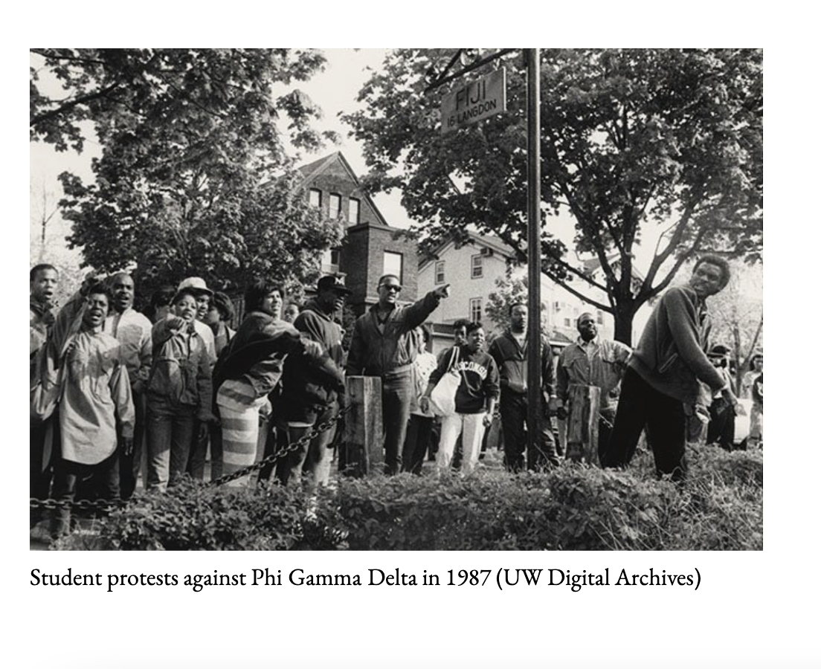

A report from the 2008-09 and 2009-10 school years offers valuable insights into students' engagement with the ESR. Its findings include:

* “Most students take a UW‐Madison Ethnic Studies course to satisfy the Ethnic Studies graduation requirement.”
* “Around one in three (31%) UW‐Madison graduates satisfied the Ethnic Studies requirement during their first two semesters of enrollment at UW‐Madison.”
* “Two particular Ethnic Studies courses account for 36% of the courses used to satisfy the Ethnic Studies requirement. These two courses, Anthropology 104 and Sociology 134, are the most frequently taken Ethnic Studies courses by graduates in every school/college” (These two courses are still the most common according to a study on 2016-17 graduates.) [2].

A 2012 report from the University General Education Committee recommended that undergraduates complete their ESR as part of their first 60 credits at UW. The percentage of freshmen who completed their ESR within their first four semesters increased from 58% in Fall 2013 to 71% in Fall 2015 [3]. According to a report from the 2016-17 school year, around 79% of undergraduates enrolled in a single ethnic studies course, 15%-16% enrolled in two ethnic studies courses, and roughly 6% enrolled in three or more.

Today, the university designates the ESR as the following [4]: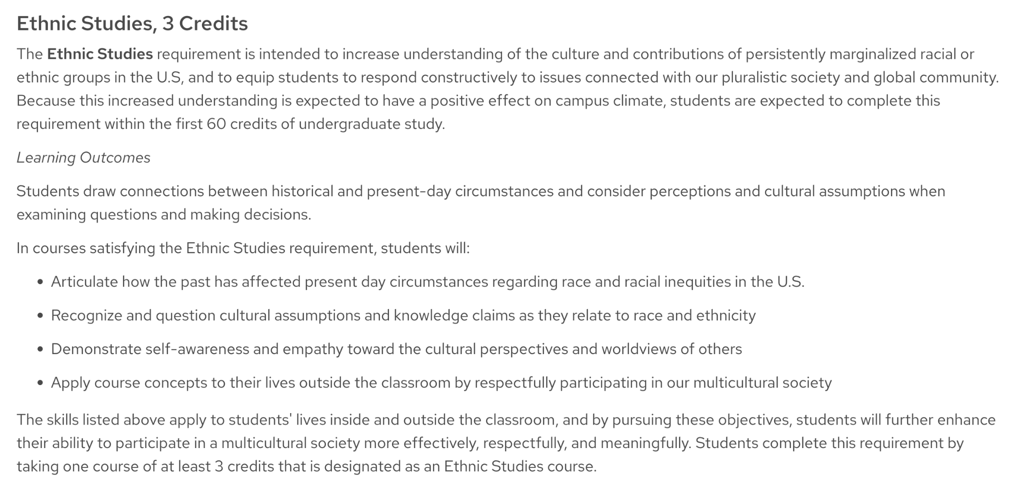

Ultimately, the ESR is far from a cure; instead, it serves as a makeshift solution to address the racism and discrimination embedded in the historical and contemporary fabric of campus culture and policies. Most degree programs at UW do not mandate the inclusion of an ethnic studies course. Consequently, in the absence of this requirement, a significant number of students would lack exposure to this vital content. The ESR is not a perfect solution, but in the meantime, its existence within the university is critical in broadening students' perspectives on campus life and fostering a more comprehensive worldview.

(More visuals below)

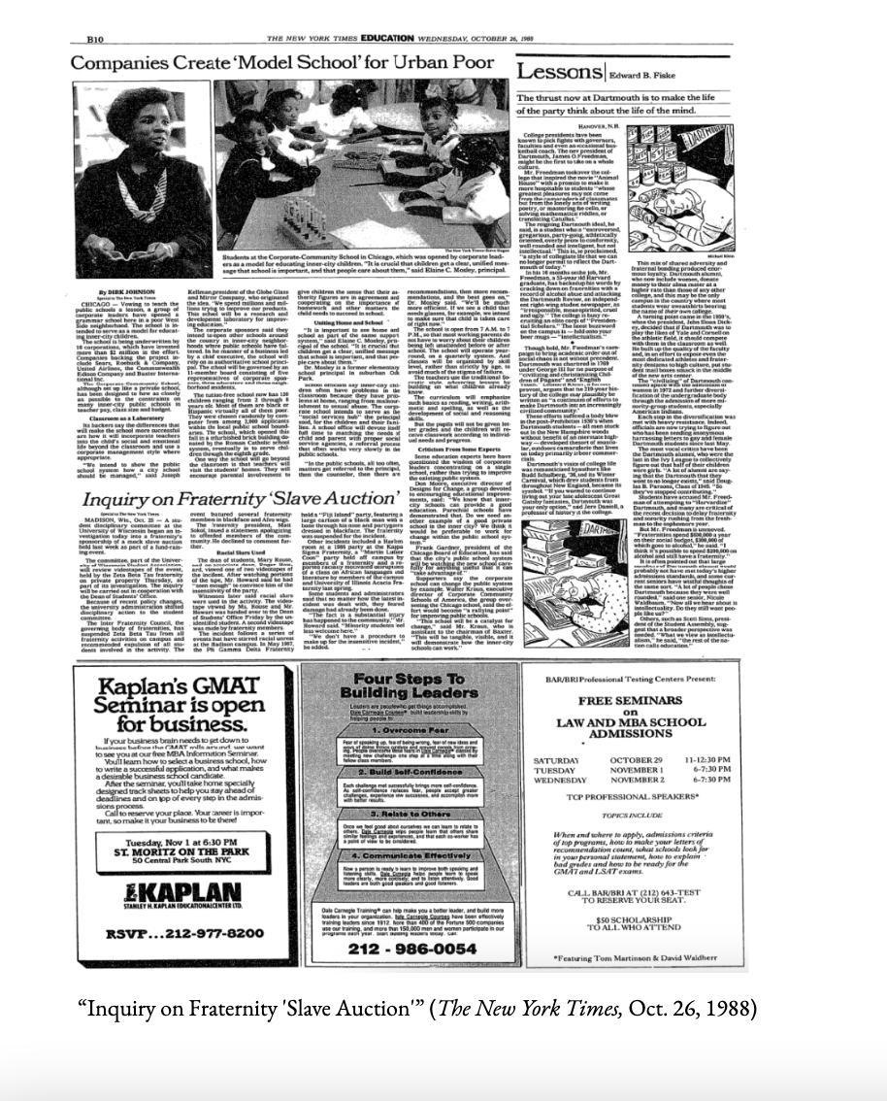

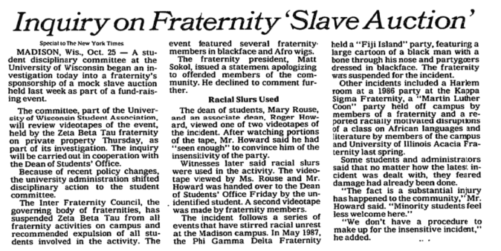

[1] <https://gened.wisc.edu/wp-content/uploads/sites/991/2019/05/esreviewreportandaction.pdf>

[2] <https://gened.wisc.edu/wp-content/uploads/sites/991/2019/05/Ethnic_Studies_Analysis.pdf>

[3] <https://gened.wisc.edu/wp-content/uploads/sites/991/2019/05/2017-Ethnic-Studies-Update.pdf>

[4] <https://policy.wisc.edu/library/UW-1059>